SLIEVEARDAGH NS
The Commons, Thurles, Co. Tipperary
Roll No. 11470B

Wellbeing Policy

Mission Statement
At Slieveardagh NS we promote a caring, supportive environment in which each individual is valued and respected. We recognise that all children and staff need the foundation of positive mental health to benefit fully from all the opportunities available to them.
Rationale
Why does our school require a Wellbeing Policy?
Everyone experiences life challenges that can make us vulnerable. At times, anyone may need additional support to maintain or develop good mental health and wellbeing.
- 1 in 10 children and young people aged 1-15 years have a clinically recognisable mental disorder in any one year.
- 1 in 4 adults will experience mental health difficulties in their life time.
The mental health of children, staff, parents and carers and the wider community will impact on all areas of development, learning, achievement and experiences.
All children have a right to be educated in an environment that supports and promotes the positive wellbeing for all. Likewise all staff has the right to work in an environment that supports and promotes positive wellbeing for all.
Slieveardagh NS recognises these needs and rights and is committed to:
- Raising awareness,
- Increasing understanding and
- Ensuring that the school makes a difference by providing a place where all children and staff feel 1) safe, 2) secure and 3) able to achieve and experience success and well-being.
Whole School Approach
A multi-component, preventative, whole school approach to the promotion of well-being is the priority for Slieveardagh NS. This whole school approach involves all members of the school community engaging in a collaborative process of change to improve specific areas of school life that impact on well-being.
By adopting a whole school approach Slieveardagh NS aims to produce a wide range of educational and social benefits for our pupils, including improved behaviour, increased inclusion, improved learning, greater social cohesion and improvements to mental health.
Central to this, is the role of the Slieveardagh NS staff and the importance of building professional capacity to engage in a reflective process to implement and sustain well-being policy and strategies from within.

Benefits of promoting Well-being in Slieveardagh NS
By implementing a whole school approach to well-being the benefits include:
- Better learning results for pupils.
- More done to promote staff health.
- A co-ordinated approach to social, physical and environmental needs.
- Increased pupil self-esteem.
- Lowered incidence of bullying.
- School environment is safer and more secure.
- Better understanding of schools’ health aims.
- Improved relationships within the school.
- More involvement of parents/guardians.
- Better use of outside agencies.
The Department’s Well-being policy Statement and Framework
The Department’s Wellbeing Policy Statement and Framework for Practice assists schools in ensuring that well-being promotion is embedded within the school’s existing practice. This framework provides guidance and practical resources to assist in the further enhancement of whole school approaches to well-being promotion, in the areas of:
- Culture and environment
- Curriculum (Teaching and Learning)
- Policy and planning
- Relationships and partnerships
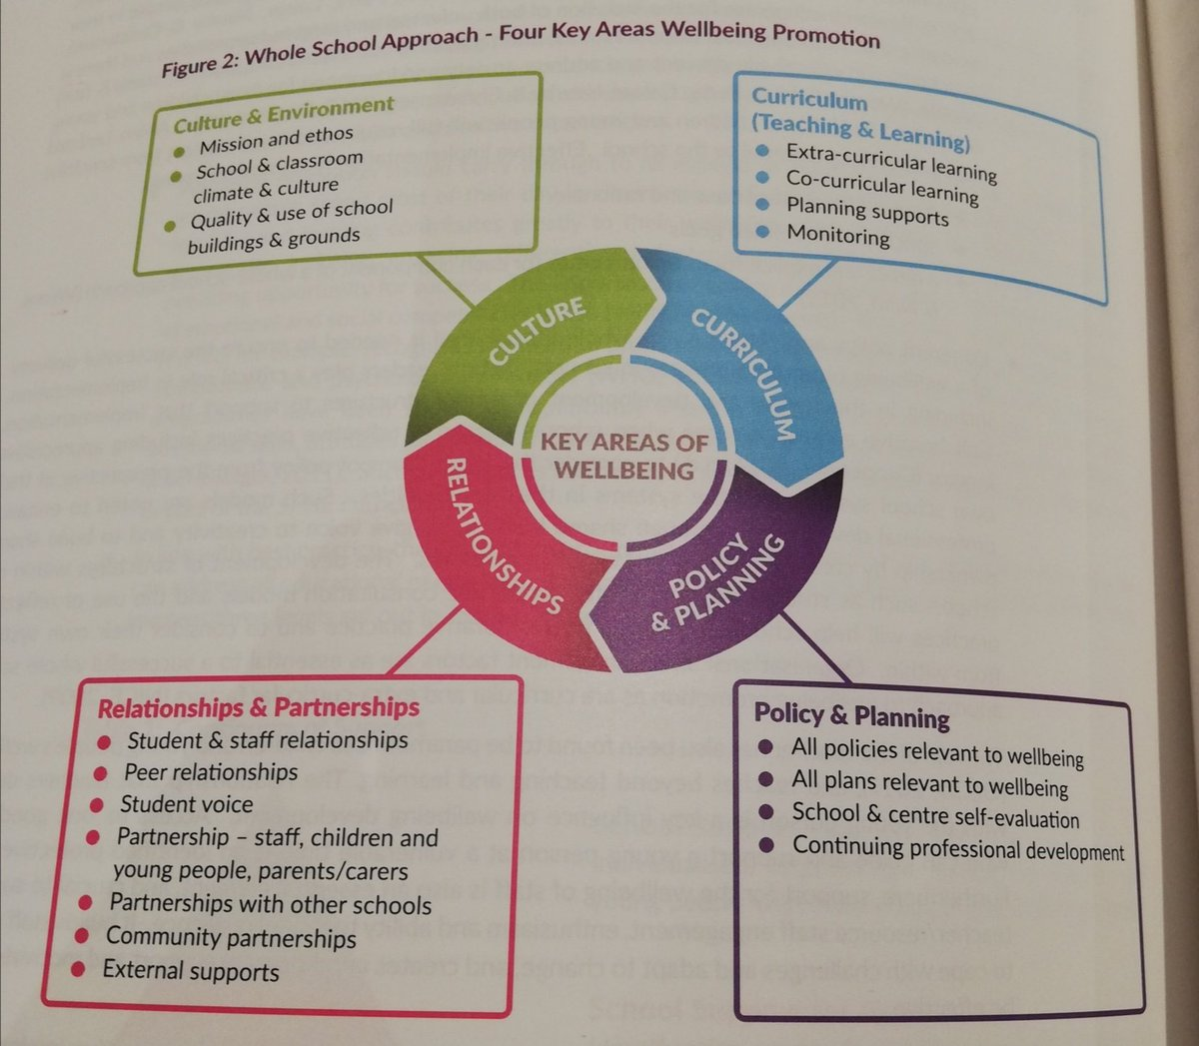

Well-being at Slieveardagh NS
Section 1: Wellbeing for All
- Wellbeing and Child Protection and other Statutory obligations
- Wellbeing and Care
- Wellbeing and Curriculum
- Wellbeing and the Classroom/School-yard
- Wellbeing and Inclusion/Equality
- Learning about Wellbeing
Section 2: Wellbeing for specific targeted children
- Wellbeing for Junior Infants
- Wellbeing for Children with Special Needs
- Wellbeing for Children with specific care issues
- Wellbeing and transition to 2nd Level

Section 3 Wellbeing for Teachers/SNAs

Section 1: Wellbeing for All
- Wellbeing and Child Protection and other Statutory obligations
Name of Initiative | Details | Why has this specifically to do with wellbeing?
Child Protection | See Child Protection Policy | The school fully complies with the policy and practice of Children First and the Principal undertakes the role of DLP with diligence. The DLP reports concerns of neglect/abuse to social services, and reports same to BOM at each meeting. The school endeavours to support the families about whom any such reports have been made.
Attendance and Punctuality | See Attendance Strategy | The proactive measures of the Attendance Strategy are fully observed and the BOM is updated at each meeting.
Health and Safety | See Heath and Safety Statement | The school endeavours to be a healthy and safe place for children, teachers, SNA, other employees, parents and visitors alike. A specified BOM member, in conjunction with the Principal, ensures the Health and Safety Statement is fully complied with.
Code of Behaviour and Anti-Bullying Policy | See both Policies | Both of these Codes have been maximally designed with view to the wellbeing of the children and their flourishing in this school. These policies include ‘positive’ aspects which the school teaches and includes in the annual calendar as ‘pre-emptive’ and ‘preventative’ of issues of indiscipline or bullying arising, and then also strategies that are fair and reasonable for dealing with such issues when they occur. Taught programmes of Children’s Rights and Human Rights are conducted from Junior Infants to 6th classes. . Stay Safe and other personal development programmes are taught as part of the school’s SPHE, and RSE programmes.
Student Council and Green Team Council |  | Designed in order to ensure children’s voice and democratic practice in the day-to-day running of the school.
Acceptable Usage Policy for ICT and Anti-Bullying ( cyber-bullying/social media) | See policies | Optimally designed to equip the children with the skills of self-regulation and self-protection in their use of ICT and social media.
Parent Teacher Meetings and summer reports | Parents are facilitated with a formal parent-teacher meeting in the year and end of year summer reports. | The teachers will always give detailed descriptions of the child’s wellbeing at PT meetings, and highlight to parents what specific wellbeing programme is in place for the ‘targeted’ child, if this should be the case.

- Wellbeing and Care
Name of Initiative | Details | Why has this specifically to do with wellbeing?
‘Targeted’ families | See HSCL | The HSCL establishes various ‘sets’ of targeted families (for various criteria) with specific supports in place for families and children for each of these criteria.
School Lunches |  | In the selection of the provider of these attention is given the nutritional value of the food.
Book Rental and Minimum Costs | The school leads the way in ensuring that minimum costs are visited upon parents and the DEIS grant is prioritised to ensure that the children’s learning is resourced maximally and in keeping with best contemporary facilities and practice. | The school ensures that costs of school-going are minimised for all our families through processes of book-rental, bulk-buying from publishers, effective resource-management and school storage etc.

- Wellbeing and Curriculum
Name of Initiative | Details | Why has this specifically to do with wellbeing?
SPHE | The SPHE Curriculum remains the primary legitimating for the teaching of wellbeing in the school. See SPHE Statement. | The three strands of SPHE are taught through both integrated cross-curricular themes and also discretely in SPHE lessons. Pedagogies also include Whole School Assemblies conducted by the Principal and staff. The school teaches Weaving Wellbeing as the primary wellbeing programme. The school teaches from Walk Tall and a plethora of other approved texts/programmes as set out in the school’s anti-bullying, discipline and SPHE/RSE programmes.
Physical Education | The PE curriculum provides an ideal opportunity to enhance children’s experience of wellbeing. | P.E. Principles such as ‘sport for all’, finding ‘my own sporting talent’ ‘the benefits of exercise’ ‘healthy lifestyle/eating’ permeate our PE schedules with a view to optimising the children’s wellbeing
Drama per se | The Drama class is an ideal setting for exploratory work on the emotional ( ‘feelings’) aspects of wellbeing | Through drama-principles of role-play, improvisation, conscience-alley and hot-seat the children are encouraged to explore their experiences of friendship/bullying. Inclusion/exclusion, exploring emotions, equality/inequality , assertiveness, body language
The Arts (Visual Arts, Drama and Music ) and Science | Both of these Curricula offer the opportunity for children to experience happiness and joy through developing their own expressive and enquiry talents | In addition to the classroom work as set out in the curriculum, the children also experience music and Visual Art through Arts Week, STEM week, educational visits to galleries and theatres and concert halls, visiting drama groups, film-making projects, and Young Scientist.

- Wellbeing and the Classroom/School-yard
Name of Initiative | Details | Why has this specifically to do with wellbeing?
School Year Supervision | The school yard is supervised diligently and responsibly by all teachers/SNAs on a rota basis. Our playtimes are characterised by principles of ‘freedom’, and ‘pupil choice’ (all spaces are multi-aged so as to facilitate sibling-friendships and friendship with others outside of one’s own class. | Principles of ‘choosing what to do’, making new friends beyond my class’, ‘releasing tension’ ‘freedom’ ‘vigorous and robust exercise’ ‘mixed-age play settings’ characterise the philosophy of our playground protocols.
Children’s Voice | Our classrooms are to be places of discussion. Children are to be optimally allowed to express their opinions, voice their feelings, genuinely dialogue with teacher and peers, exercise freedom of expression throughout the school day. | Pedagogies include heavy emphasis on oral discussion as per First Steps programme, circle times, free writing journals, Student Council and Green Team Council. The teaching of science, history and geography are to be conducted through enquiry methodologies and active/discovery learning. In all classroom activities children are to be given maximal opportunity for active participation and agency.

- Wellbeing and Inclusion/Equality
Name of Initiative | Details | Why has this specifically to do with wellbeing?
Inclusion of children with special needs | A number of children with SEN have chosen to come to our school prompting a root and branch review of SEN-Inclusion and Wellbeing practice in the school. | All teachers work closely as a team to ensure that children with SEN have designed plans specifically to their individual needs which can be met in the mainstream-setting, the SEN setting and the school-yard. These specific measures are included in the children’s Individual Education Plans and outlined to parents at IEP review meetings. These plans are richly imbued with actions pertaining to wellbeing.
Inclusion of children with pre-identified patterns or conditions of isolation | Children coming to our school are either pre-identified or early-identified as children with patterns of behaviour or responses that leave them isolated or struggling to form inclusionary dispositions and around whom there may be concerns for their general wellbeing. This especially applies to children who join the school from Senior Infant to 6th (as opposed to from Day 1 in junior Infants). | The principal and all teachers work closely with these families and provides a wide range of supports for the family/children in order to address patterns of school-going that are proving problematic for the child.

- Learning about Wellbeing
Name of Initiative | Details | Why has this specifically to do with wellbeing?
SPHE and RSE | The school’s SPHE and RSE curricula are the primary place where children learn about Wellbeing as a subject in itself. The 1999 revised curriculum is an excellent framework for this teaching and learning. | The teacher resources his/her SPHE teaching from agreed and school-sanctioned programmes:  Stay Safe  Walk Tall  Weaving Wellbeing  Lift Off  The Rights Start  And to incorporate.....  Incredible Years  Friends for Life
Drama | The Drama lesson is used to explore ranges of emotions and how to respond through the process driven lessons as set out in the 1999 Curriculum
PE and Sport | Learning about healthy lifestyles, healthy eating and the value of exercise are essential parts of the school’s PE and Sport curriculum.

Section 2: Wellbeing for specific targeted children
- Wellbeing for Junior Infants
Name of Initiative | Details | Why has this specifically to do with wellbeing?
Registration | Each family has a registration meeting with the principal where the parents are invited to talk about the child, his/her history and personality | Parents enjoy the opportunity of relaying their account of their child. It is an opportunity to talk about any issues to complement the other information gathered through forms etc.
Pre visit to child in pres-school setting | The Principal and/or HSCL visit all the children in their pre-school setting, gathering any soft information from observation and conversation with pre-school teacher. | Sometimes issues of wellbeing such as interaction in play and social interaction can be observed that can be useful for pre-planning for children who may have difficulties in this regard from Day 1 in our school.
Formal Junior Infant Induction Day | Parents and incoming Junior Infant children have a formal day in June. Here, the children are brought to their classrooms and given a welcome to the school plus a couple of hours of typical JI activities. Teachers converse with and observe the children. The parents attend an assembly where the ethos and practice/protocols of the school are set out by the Principal and where there is a question/answer session. | This is a further opportunity for observation/feedback and conversations with parents where the wellbeing of the child in our school can be optimally planned.
Induction period | The JI children have an induction period for the first two weeks of the school year with a shortened day. Teachers over this period work hard to ensure they introduce the child to the protocols of the school and the school yard, and to converse with parents so as to optimally ensure the children’s wellbeing in the school | The children take tours of the school, meet all the people they are likely to interact with etc. They are introduced to schoolyard activities and spaces. They are gradually introduced to protocols of exiting and re-entering the school as a group/class. Protocols of parent-teacher interaction are established.

- Wellbeing for Children with Special Needs
Name of Initiative | Details | Why has this specifically to do with wellbeing?
Children with Special Needs ranging from diagnosed and specific disorders to non-diagnosed ongoing issues are given extra attention in the school on issues of wellbeing. | The SEN teaching team in conjunction with the Principal and teachers identify the specific wellbeing issues of these children. Where the child has RT and an IEP these are written in here and form part of the ongoing provision for the child.
The Multi Sensory Room  (In development) | A multisensory room will be developed to allow children, who are identified as needing time-outs, sensory-breaks or private-space, to avail of this.
IEPs and IBPs | Individual Support Plans, including IEPs and IBPs, are developed for targeted children, often with wellbeing issues to the forefront, and carried out by the SEN team.

- Wellbeing for Children with specific care issues
Name of Initiative | Details | Why has this specifically to do with wellbeing?
Medical Issues | The school teachers and SNAs endeavour to act generously and diligently where medical interventions that require the teachers to administer ( medicines, epi-pens, allergies, medication) | The child’s experience of having to receive medical intervention during the school day can be a source of great stress to the child/family, the school endeavours to act in loco parentis in generous spirit and to be accommodating to specific requirements of attendance, punctuality, privacy , communication and observation as required.
Health Professionals | The school is willing to assist other health professionals in their care for the child. | The school, in collaboration with the parents, can sustain and develop inputs into the child’s teaching/learning as required by the child’s external-agencies in certain circumstances and in accordance with policy/protocol.

- Wellbeing and transition to 2nd Level
Name of Initiative | Details | Why has this specifically to do with wellbeing?
Liaison with all 2nd level schools | Time and Effort is put in by the 6th class teachers to ensure that the ‘Passport’ is complied with and done with good quality, including the children’s own reportage of self-description and their hopes and aspirations | Emphasis on potential issues of wellbeing at second level is included in these documents.

Section 3 Wellbeing for Teachers/SNAs
Name of Initiative | Details | Why has this specifically to do with wellbeing?
Governance | The BOM of the school observe it as their priority that they act as a fair and just employer and with specific interest in the wellbeing of their employees | The BOM meetings refer to issues of employer responsibility to employee wellbeing. The BOM liaise with Medmark when necessary for advice on best-practice. The BOM liaise with the DES and CPMSA on issues of governance and wellbeing.
School Leadership | The school leadership observes the sustenance and development of the wellbeing of the teachers/SNAs is both important in itself and also an important factor in teachers and SNAs doing their jobs to the best of their abilities. | School leadership endeavours to ensure that unnecessary stressors are minimised and that all administrative and strategic decisions are made in collaboration and maximally democratically. The school leadership aims to foster good dialogical relations with the teachers. Every effort is made to ensure that the teacher have resources and a building that does not impact negatively on their business.
Continuous Professional Development | Teachers are encouraged to attend courses of CPD, including those courses which specifically refer to teaching about Wellbeing. | Improves staff well-being skills.

Ratification
- Developed by staff in May - June 2020
- Ratified by the Board of Management of Slieveardagh National School on -__________
Signed by the Chairperson______________.

